**ASSIGNMENT 1 FRONT SHEET**

|  |  |  |  |
| --- | --- | --- | --- |
| **Qualification** | **BTEC Level 5 HND Diploma in Computing** | | |
| **Unit number and title** | Unit 2: Networking Infrastructure | | |
| **Submission date** | 14.12.2021 | **Date Received 1st submission** |  |
| **Re-submission Date** |  | **Date Received 2nd submission** |  |
| **Student Name** | Do Huu Duy | **Student ID** | GCC200018 |
| **Class** | GCC0903 | **Assessor name** | Le Huynh Quoc Bao |
| **Student declaration**  I certify that the assignment submission is entirely my own work and I fully understand the consequences of plagiarism. I understand that making a false declaration is a form of malpractice. | | | |
|  |  | **Student’s signature** | huuduy |

**Grading grid**

|  |  |  |  |  |  |  |
| --- | --- | --- | --- | --- | --- | --- |
| P1 | P2 | P3 | P4 | M1 | M2 | D1 |
|  |  |  |  |  |  |  |

|  |  |  |
| --- | --- | --- |
| **❒ Summative Feedback: ❒ Resubmission Feedback:** | | |
| **Grade:** | **Assessor Signature:** | **Date:** |
| **Lecturer Signature:** | | |

# Assignment Brief 1 (RQF)

## Higher National Certificate/Diploma in Computing

|  |  |
| --- | --- |
| **Student Name/ID Number:** |  |
| **Unit Number and Title:** | **Unit 2: Networking** |
| **Academic Year:** | **2021 – 2022** |
| **Unit Assessor:** | **Van Ho** |
| **Assignment Title:** | **Networking Infrastructure** |
| **Issue Date:** | **April 1st, 2021** |
| **Submission Date:** |  |
| **Internal Verifier Name:** |  |
| **Date:** |  |
| **Submission Format:** | |
| *Format:*   * The submission is in the form of an individual written report. This should be written in a concise, formal business style using single spacing and font size 12. You are required to make use of headings, paragraphs and subsections as appropriate, and all work must be supported with research and referenced using the Harvard referencing system. Please also provide a bibliography using the Harvard referencing system.   *Submission*   * Students are compulsory to submit the assignment in due date and in a way requested by the Tutor. * The form of submission will be a soft copy posted on <http://cms.greenwich.edu.vn/>. * Remember to convert the word file into PDF file before the submission on CMS.   *Note:*   * The individual Assignment *must* be your own work, and not copied by or from another student. * If you use ideas, quotes or data (such as diagrams) from books, journals or other sources, you must reference your sources, using the Harvard style. * Make sure that you understand and follow the guidelines to avoid plagiarism. Failure to comply this requirement will result in a failed assignment. | |
| **Unit Learning Outcomes:** | |
| **LO1 Examine networking principles and their protocols.**  **LO2 Explain networking devices and operations.** | |
| **Assignment Brief and Guidance:** | |
| **Assignment scenario**  **You are employed as a network engineer by Nguyen Networking Limited, a high-tech networking solution development company, which has branches in Ho Chi Minh City, Hanoi, Da Nang and Can Tho. The company has been contracted to implement a networking project from a local educational institute. The specification of the project is given below:**   * **People: 200 students, 15 teachers, 12 marketing and administration staff, 5 higher managers including the academic heads and the programme managers, and 3 computer network administrators.** * **Resources: 50 student lab computers, 35 staff computers, and 3 printers.** * **Building: 3 floors, all computers and printers are on the ground floor apart from the IT labs – one lab located on the first floor and another located on the second floor.**   **Task 1**  **The CEO of the company, Mr. Nguyen, has asked you to investigate and explain networking principles, protocols and devices and submit a report.**  **You will need to produce a report that includes the following:**   * **An introduction to provide an overview of your report.** * **Benefits and constraints of different types of networks and networking standards.** * **The impact of network topology, speed of communication and bandwidth requirements.** * **Effectiveness of networking systems.** * **Discussion on operating principles of networking devices and server types and networking software.** * **Discuss the relationship of workstation hardware with networking software.** * **Explore a range of server types and justify the selection of a server, considering a given scenario regarding cost and performance optimization.** * **For the given specification, identify the topology protocol for the efficient utilization of a networking system.** | |

Table of Contents

**Assignment Brief 1 (RQF) 2**

**Higher National Certificate/Diploma in Computing 2**

**I. Discuss the benefits and constraints of different network types and standards (P1). 6**

**1. What is a network? 6**

**2. Some type of network that are popular. 6**

**3. What is a network protocol? 14**

**4. What is the purpose of protocol? 17**

**5. Some common protocols. 17**

**6. list the international standard organizations and the names of the standards used in networking. 23**

**II. Explain the impact of network topology, communication and bandwidth requirements (P2). 24**

**1. What is network topology? 24**

**2. What is a physical and logical topology and the difference between them? 24**

**3. Some common topologies. 26**

**4. What is network communication? 32**

**5. What is bandwidth? 33**

**III. Discuss the operating principles of networking devices and server types (P3) 33**

**1. Some popular network devices and how these devices operate in a network. 33**

**2. Some other common networking devices and specify their uses, and under what circumstances. 38**

**3. Some common types of servers and state the use of each server type. 41**

**IV. Discuss the inter-dependence of workstation hardware with relevant networking software (P4) 44**

**1. The meaning of interdependence. 45**

**2. What is workstation hardware and networking software? 45**

**3. The independence of the workstation hardware and networking software. 46**

**V. Compare common networking principles and how protocols enable the effectiveness of networked systems (M1) 47**

**1. Circuit switching. 47**

**2. Packet switching. 47**

**3. Circuit Switching vs Packet Switching Comparison. 47**

**4. The Advantages and Disadvantages of Circuit Switching. 48**

**5. The Advantages and Disadvantages of Packet Switching. 49**

**6. The protocols enable networked systems to connect efficiently using Circuit Switching principle. 50**

**7. The protocols enable networked systems to connect efficiently using Packet Switching principle. 51**

**VI. Explore a range of server types and justify the selection of a server, considering a given scenario regarding cost and performance optimisation (M2) 51**

**1. Explore a range of common server types and give a brief outline of their uses. 51**

**2. My choice for this scenario. 52**

**VII. Considering a given scenario, identify the topology protocol selected for the efficient utilization of a networking system (D1) 52**

**1. Scenario. 52**

**2. My solution. 53**

**References 54**

1. **Discuss the benefits and constraints of different network types and standards (P1).**
2. **What is a network?**

* In information technology, a network is defined as **the connection of at least two computer systems**, either by a cable or a wireless connection. The simplest network is a combination of two computers connected by a cable. This type of network is called a peer**-to-peer network.** There is no hierarchy in this network; both participants have equal privileges. Each computer has access to the data of the other device and can **share resources** such as disk space, applications or peripheral devices (printers, etc.).
* Today’s networks tend to be a bit more complex and don’t just consist of two computers. Systems with more than ten participants usually use client-server networks. In these networks, a central computer (server) provides resources to the other participants in the network (clients). (ionos, 2020)

1. **Some type of network that are popular.**

* **LAN (Local Area Network):**
* Local Area Network is a group of computers connected to each other in a small area such as building, office.
* LAN is used for connecting two or more personal computers through a communication medium such as twisted pair, coaxial cable, etc.
* It is less costly as it is built with inexpensive hardware such as hubs, network adapters, and ethernet cables.
* The data is transferred at an extremely faster rate in Local Area Network.
* Local Area Network provides higher security. (javatpoin, 2021)

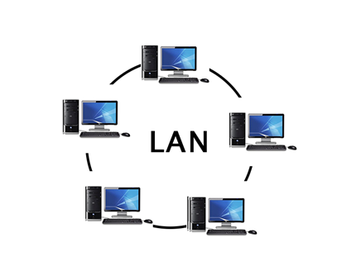

* **Advantages of LAN:**
* Inexpensive transmission media.
* It can simplify the physical association of a device to the media.
* It is used to high data transmission rates.
* Network data transmission is independent of the connected devices rates, making it accessible for the one-speed device to send data to another speed device.
* A large rate of interconnection between devices.
* Each connected device has the potential to interact with another device on the network.
* It is flexible and growth-oriented.
* It allows file locking.
* It provides full proof of the security system against illegal access to data.
* LANs are a productivity tool. In the case of business, a LAN should be an apparent contributor to raised profitability.
* **Disadvantages of LAN:**
* LAN software needed a memory area in each of the mainframe used on the network. This decreases the memory space available for the user’s program.
* Local area networking adds another phase of difficulty to the computer operation. Users can have a problem in understanding the network commands. The installation and authority of a LAN require far more technical and regulatory skills than installing and handling multiple computers that are not networked.
* Some security system should be executed if it is essential to protect private data.
* Some control on the part of the customer is lost. We have to share a printer with different customers.
* Some current application programs will not run in a network environment. (tutorialspoint, 2021)
* **WAN (Wide Area Network):**
* A Wide Area Network is a network that extends over a large geographical area such as states or countries.
* A Wide Area Network is quite bigger network than the LAN.
* A Wide Area Network is not limited to a single location, but it spans over a large geographical area through a telephone line, fibre optic cable or satellite links.
* The internet is one of the biggest WAN in the world.
* A Wide Area Network is widely used in the field of Business, government, and education. (javatpoint, 2021)

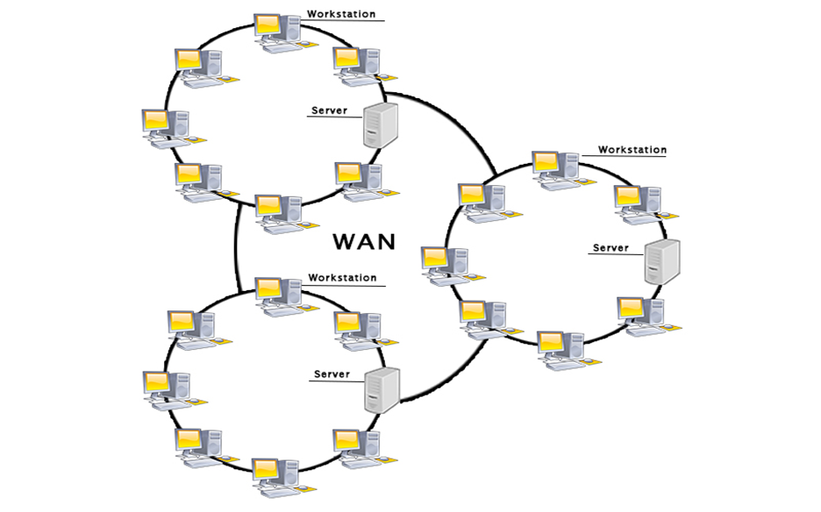

* **Advantages of WAN:**
* Geographical area: A Wide Area Network provides a large geographical area. Suppose if the branch of our office is in a different city then we can connect with them through WAN. The internet provides a leased line through which we can connect with another branch.
* Centralized data: In case of WAN network, data is centralized. Therefore, we do not need to buy the emails, files or back up servers.
* Get updated files: Software companies work on the live server. Therefore, the programmers get the updated files within seconds.
* Exchange messages: In a WAN network, messages are transmitted fast. The web application like Facebook, Whatsapp, Skype allows you to communicate with friends.
* Sharing of software and resources: In WAN network, we can share the software and other resources like a hard drive, RAM.
* Global business: We can do the business over the internet globally.
* High bandwidth: If we use the leased lines for our company then this gives the high bandwidth. The high bandwidth increases the data transfer rate which in turn increases the productivity of our company.
* **Disadvantages of WAN:**
* Security issue: A WAN network has more security issues as compared to LAN and MAN network as all the technologies are combined together that creates the security problem.
* Needs Firewall & antivirus software: The data is transferred on the internet which can be changed or hacked by the hackers, so the firewall needs to be used. Some people can inject the virus in our system so antivirus is needed to protect from such a virus.
* High Setup cost: An installation cost of the WAN network is high as it involves the purchasing of routers, switches.
* Troubleshooting problems: It covers a large area so fixing the problem is difficult.
* **MAN (Metropolitan Area Network):**
* A metropolitan area network is a network that covers a larger geographic area by interconnecting a different LAN to form a larger network.
* Government agencies use MAN to connect to the citizens and private industries.
* In MAN, various LANs are connected to each other through a telephone exchange line.
* The most widely used protocols in MAN are RS-232, Frame Relay, ATM, ISDN, OC-3, ADSL, etc.
* It has a higher range than Local Area Network (LAN). (javatpoint, 2021)

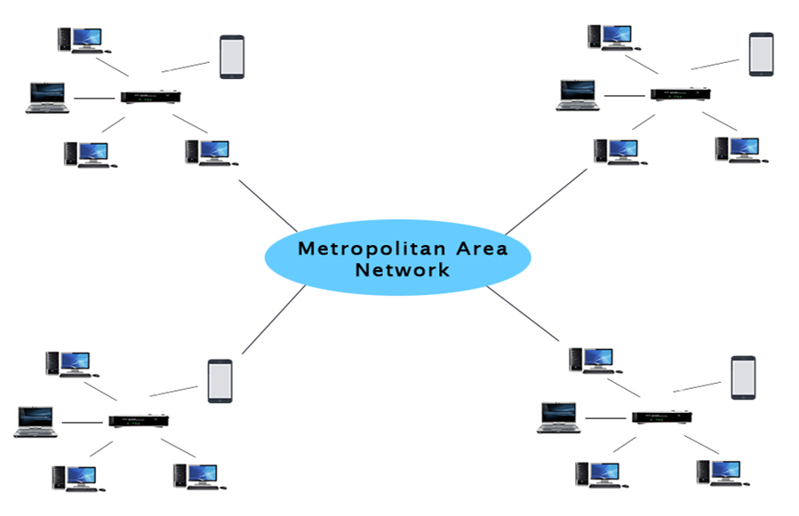

* **Advantages of MAN:**
* Cost: MAN utilizes very less number of resources compared to WAN. Hence, implementation costs are greatly reduced. Moreover combining both MAN and WAN network is less expensive. Besides all the data on the MAN network has been managed very efficiently in a centralized way. Therefore, MAN is highly cost effective.
* Email Service: Sending massages through email is quite efficient in MAN. Every Email that is being sent through MAN is of free charge and of high speed.
* Speed: MAN often uses fiber optics cables for its data transmission. Fiber optics cable are capable of offering speed up to 1000Mbps. Hence, data and information can be transferred at a faster rate.
* Internet Sharing: Using MAN, users can share their internet connections with other users. By this way all the MAN users can experience high speed internet connectivity.
* Network Conversion: As mentioned earlier MAN is a mixture of two or more LAN networks. Since LAN has fast configuration of links, two LAN networks can be connected quickly.
* **Disadvantages of MAN:**
* Maintenance: MAN generally is difficult to manage especially when it becomes large. This is mainly due to safety issues and other additional configurations.
* Security: The probability of hackers attacking a MAN network is very high comparing to LAN. Thus, data has the tendency to get hacked easily. In order for securing the data, well trained staffs and safety equipments are needed.
* Technical Assistance: For installing a MAN network without any faults, it requires technical people with experience. The technical assistance needs to be from network administrators and troubleshooters. This can overall increase the installation cost.
* Wire Requirement: Comparing to LAN and WAN, MAN requires additional wires for its operations. This is mainly due to the connection of two LAN networks. When there is a need of more wires, then there will be more cost in the network as well.
* Internet Speed: In order for its operations, MAN requires fiber optics cables which is quite expensive. It cannot operate on traditional copper wires that is normally present on a telephone. Despite of this if the MAN is installed, users have to experience very slow internet speeds.(hitechwhizz, 2020)
* **PAN (Personal Area Network):**
* Personal Area Network is a network arranged within an individual person, typically within a range of 10 meters.
* Personal Area Network is used for connecting the computer devices of personal use is known as Personal Area Network.
* Thomas Zimmerman was the first research scientist to bring the idea of the Personal Area Network.
* Personal Area Network covers an area of 30 feet.
* Personal computer devices that are used to develop the personal area network are the laptop, mobile phones, media player and play stations.
* **There are two types of Personal Area Network:**
* Wired Personal Area Network: Wired Personal Area Network is created by using the USB.
* Wireless Personal Area Network: Wireless Personal Area Network is developed by simply using wireless technologies such as WiFi, Bluetooth. It is a low range network.(javatpoin, 2021)

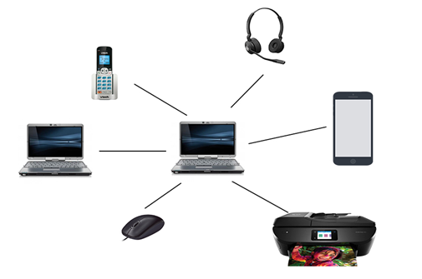

* **Advantages of PAN:**
* Wire Requirement: In PAN type of network, there is no need for extra wires. Therefore, users no need to worry about cable management and floor space. For establishing a connection between two devices there should be only bluetooth enabled. Thus, PAN is considered to be highly cost effective.
* Device Connectivity: Using Personal Area Network you can connect many of the devices to one single device at the same time. For an example a single mobile phone can be used to connect many peripherals such as keyboard, mouse and printers or even another mobile so that files can be shared conveniently.
* Reliability: PAN networks can be always ensured reliable and stable whenever the connection is established 10 meters range.
* Security: PAN networks are considered to be safe and secure more than any other network since all the devices and data are authorized. Hence, it is almost impossible to hack or cause interference to devices here.
* Synchronization: Data synchronization is made easy in Personal Area Network. Which means that data has the capability to get synchronized between different devices. For an example devices connected with PAN network can be used to exchange, download and upload data.
* Portability: Since PAN is wireless, users can move devices wherever they want and exchange data as well. This paves the way for portability in the network.
* **Disadvantages of PAN:**
* Area Coverage: Since PAN uses short range bluetooth communication it won't be working beyond 10 meters range. This can be especially disadvantageous when making long distance data sharing.
* Signal Interference: PAN networks use infrared rays for its transmission. Therefore, it can interfere with other radio signals and experience data droppings. This can severely interrupt the communication between two devices.
* Data Transfer Rate: Comparing to other types of networks, PAN has relatively slower rate of transmission. This is mainly due to the usage of bluetooth and infrared those are slower on their nature.
* Health Issues: Since PAN network is wireless, harmful rays such as microwave signals are being released by them. These signals can severely impact humans as well as animals causing various health effects. Such issues can include brain damage and heart related problems.
* Infrared Transmissions: Since Infrared signals are being used by PAN, it has limitations of travelling only in straight line. This can be noticeable when using TV remote. A TV remote will only be working if it is faced towards the Television, otherwise it will not.
* Cost: Unlike other types of networks, PAN is used only by devices which are high on cost. Examples of such devices are laptops, smartphones and digital cameras. Hence, it counts another disadvantages of PAN.(hitechwhizz, 2020)

1. **What is a network protocol?**

* In networking, a protocol is a set of rules for formatting and processing data. Network protocols are like a common language for computers. The computers within a network may use vastly different software and hardware; however, the use of protocols enables them to communicate with each other regardless.
* Standardized protocols are like a common language that computers can use, similar to how two people from different parts of the world may not understand each other's native languages, but they can communicate using a shared third language. If one computer uses the [Internet Protocol (IP)](https://www.cloudflare.com/learning/network-layer/internet-protocol/) and a second computer does as well, they will be able to communicate — just as the United Nations relies on its 6 official languages to communicate amongst representatives from all over the globe. But if one computer uses IP and the other does not know this protocol, they will be unable to communicate.
* On the Internet, there are different protocols for different types of processes. Protocols are often discussed in terms of which OSI model layer they belong to.(cloudflare, 2021)
* OSI model:

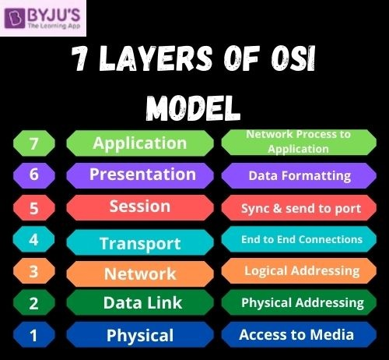

* Physical Layer:
* It is the bottom-most or the first layer of the OSI Model
* It comprises the raw data which is further transmitted to the higher layers of the structure
* Preparing the physical devices in the network and accepting the received data for transmission
* The termination of connection between two nodes of a network also takes place at this stage
* This layer converts the digital bits into electrical, radio, or optical signals
* Data Link Layer:
* Access to get the data is achieved at this layer
* It breaks the input data into frames which makes analysing the data easier
* Ensures that the data received is free of any errors
* It controls the flow of data in the stipulated time duration and along with a set speed of transmission
* The data is sent to the next layer in the form of packets which are then reviewed for further processing
* Network Layer:
* It acts as a network controller
* Transferring of variable data from one node to another, connected in a network, takes place at this layer
* Each node has a specific address and the network layer ensures that the data is sent to its destination address
* The data is sent in the form of fragments which are then connected to each other once the processing is done
* Transport Layer:
* The delivery of data packets is managed by the transport layer
* It manages the flow of data, segmentation and desegmentation and error control
* There are five classes of the transport protocol, starting from 0 and continuing till 4 (TP0 to TP4)
* Fragmentation and reassembly of data packets occur that this stage
* Session Layer:
* The connection between the computers connected in a network is managed at this layer
* Establishment, management and termination between the remote and local application takes place here
* Authentication and authorisation happen at this layer
* This layer can also terminate or end any session or transmission which is complete
* Presentation Layer:
* The data is converted into the syntax or semantics which an application understands
* Before passing on the data any further, the data is formatted at this stage
* Functions including compression, encryption, compatible character code set, etc. are also done at this layer of the model
* It serves as a data translator for the network
* Application Layer:
* The interaction with the user or the user application takes place at this stage
* When identifying communication partners, the application layer determines the identity and availability of communication partners for an application with data to transmit. (byjus, 2021)

1. **What is the purpose of protocol?**

* specifying the bandwidth of the channel or medium for each type of communication
* specifying the device operating systems that will support the communication
* providing the rules required for a specific type of communication to occur
* dictating the content of the message sent during communication**.** (mnccertified, 2021)

1. **Some common protocols.**

* **DHCP: Dynamic Host Configuration Protocol:**
* DHCP is a communication protocol that enables network administrators to automate the assignment of IP addresses in a network. In an IP network, every device connecting to the internet requires a unique IP. DHCP lets network admins distribute IP addresses from a central point and automatically send a new IP address when a device is plugged in from a different place in the network. DHCP works on a client-server model.
* Advantages:
* Centralized management of IP addresses.
* Seamless addition of new clients into a network.
* Reuse of IP addresses, reducing the total number of IP addresses required.
* Disadvantages:
* Tracking internet activity becomes tedious, as the same device can have multiple IP addresses over a period of time.
* Computers with DHCP cannot be used as servers, as their IPs change over time.
* **DNS: Domain Name System protocol:**
* The DNS protocol helps in translating or mapping host names to IP addresses. DNS works on a client-server model, and uses a distributed database over a hierarchy of name servers.
* Hosts are identified based on their IP addresses, but memorizing an IP address is difficult due to its complexity. IPs are also dynamic, making it all the more necessary to map domain names to IP addresses. DNS helps resolve this issue by converting the domain names of websites into numerical IP addresses.
* Advantages:
* DNS facilitates internet access.
* Eliminates the need to memorize IP addresses.
* Disadvantages:
* DNS queries don't carry information pertaining to the client who initiated it. This is because the DNS server only sees the IP from where the query came from, making the server susceptible to manipulation from hackers.
* DNS root servers, if compromised, could enable hackers to redirect to other pages for phishing data.
* **HTTP: Hyper Text Transfer Protocol:**
* HTTP is an application layer protocol used for distributed, collaborative, and hypermedia information systems. It works on a client-server model, where the web browser acts as the client. Data such as text, images, and other multimedia files are shared over the World Wide Web using HTTP. As a request and response type protocol, the client sends a request to the server, which is then processed by the server before sending a response back to the client.
* HTTP is a stateless protocol, meaning the client and server are only aware of each other while the connection between them is intact. After that, both the client and server forget about each other's existence. Due to this phenomenon, the client and server can't both retain information between requests.
* Advantages:
* Memory usage and CPU usage are low because of lesser concurrent connections.
* Errors can be reported without closing connections.
* Owing to lesser TCP connections, network congestion is reduced.
* Disadvantages:
* HTTP lacks encryption capabilities, making it less secure.
* HTTP requires more power to establish communication and transfer data.
* **TCP: Transmission Control Protocol:**
* TCP is a transport layer protocol that provides a reliable stream delivery and virtual connection service to applications through the use of sequenced acknowledgement. TCP is a connection-oriented protocol, as it requires a connection to be established between applications before data transfer. Through flow control and acknowledgement of data, TCP provides extensive error checking. TCP ensures sequencing of data, meaning the data packets arrive in order at the receiving end. Retransmission of lost data packets is also feasible with TCP.
* Advantages:
* TCP ensures three things: data reaches the destination, reaches it on time, and reaches it without duplication.
* TCP automatically breaks data into packets before transmission.
* Disadvantages:
* TCP cannot be used for broadcast and multicast connections.
* **ICMP: Internet Control Message Protocol:**
* ICMP is a network layer supporting protocol used by network devices to send error messages and operational information. ICMP messages delivered in IP packets are used for out-of-band messages related to network operation or misoperation. ICMP is used to announce network errors, congestion, and timeouts, as well assist in troubleshooting.
* Advantages:
* ICMP is used to diagnose network issues.
* Disadvantages:
* Sending a lot of ICMP messages increases network traffic.
* End users are affected if malicious users send many ICMP destination unreachable packets.
* **SMTP: Simple Mail Transfer Protocol:**
* SMTP is a protocol designed to transfer electronic mail reliably and efficiently. SMTP is a push protocol and is used to send the email, whereas POP and IMAP are used to retrieve emails on the end user's side. SMTP transfers emails between systems, and notifies on incoming emails. Using SMTP, a client can transfer an email to another client on the same network or another network through a relay or gateway access available to both networks.
* Advantages:
* Ease of installation.
* Connects to any system without any restriction.
* It doesn't need any development from your side.
* Disadvantages:
* Back and forth conversations between servers can delay sending a message, and also increases the chance of the message not being delivered.
* Certain firewalls can block the ports used with SMTP.
* **Telnet: Terminal emulation protocol:**
* Telnet is an application layer protocol that enables a user to communicate with a remote device. A Telnet client is installed on the user's machine, which accesses the command line interface of another remote machine that runs a Telnet server program.
* Telnet is mostly used by network administrators to access and manage remote devices. To access a remote device, a network admin needs to enter the IP or host name of the remote device, after which they will be presented with a virtual terminal that can interact with the host.
* Advantages:
* Compatible with multiple operating systems.
* Saves a lot of time due to its swift connectivity with remote devices.
* Disadvantages:
* Telnet lacks encryption capabilities and sends across critical information in clear text, making it easier for malicious actors.
* Expensive due to slow typing speeds.
* **IMAP and IMAP4: Internet Message Access Protocol (version 4):**
* IMAP is an email protocol that lets end users access and manipulate messages stored on a mail server from their email client as if they were present locally on their remote device. IMAP follows a client-server model, and lets multiple clients access messages on a common mail server concurrently. IMAP includes operations for creating, deleting, and renaming mailboxes; checking for new messages; permanently removing messages; setting and removing flags; and much more. The current version of IMAP is version 4 revision 1.
* Advantages:
* As the emails are stored on the mail server, local storage utilization is minimal.
* In case of accidental deletion of emails or data, it is always possible to retrieve them as they are stored on the mail server.
* Disadvantages:
* Emails won't work without an active internet connection.
* High utilization of emails by end users requires more mailbox storage, thereby augmenting costs.
* **POP and POP3: Post Office Protocol (version 3):**
* The Post Office Protocol is also an email protocol. Using this protocol, the end user can download emails from the mail server to their own email client. Once the emails are downloaded locally, they can be read without an internet connection. Also, once the emails are moved locally, they get deleted from the mail server, freeing up space. POP3 is not designed to perform extensive manipulations with the messages on the mail server, unlike IMAP4. POP3 is the latest version of the Post Office Protocol.
* Advantages:
* Read emails on local devices without internet connection.
* The mail server need not have high storage capacity, as the emails get deleted when they're moved locally.
* Disadvantages:
* If the local device on which the emails were downloaded crashes or gets stolen, the emails are lost.
* **FTP: File Transfer Protocol:**
* File Transfer Protocol enables file sharing between hosts, both local and remote, and runs on top of TCP. For file transfer, FTP creates two TCP connections: control and data connection. The control connection is used to transfer control information like passwords, commands to retrieve and store files, etc., and the data connection is used to transfer the actual file. Both of these connections run in parallel during the entire file transfer process.
* Advantages:
* Enables sharing large files and multiple directories at the same time.
* Lets you resume file sharing if it was interrupted.
* Lets you recover lost data, and schedule a file transfer.
* Disadvantages:
* FTP lacks security. Data, usernames, and passwords are transferred in plain text, making them vulnerable to malicious actors.
* FTP lacks encryption capabilities, making it non-compliant with industry standards. (manageengine, 2021)

1. **list the international standard organizations and the names of the standards used in networking.**

* **What are networking standards.**

A networking standard is a document that has been developed to provide technical requirements, specifications and guidelines that must be employed consistently to ensure devices, equipment and software which govern networking are fit for their intended purpose. Standards ensure quality, safety and efficiency. Networks form one of many technology arms and there are established organizations which maintain and create their standards.

* **Some international standard organizations and the names of standards used in networking.**
* American National Standards Institute (ANSI):
* The American National Standards Institute (ANSI) is a United States-based organization responsible for US standards and assessment systems. The standards established by this group are geared towards strengthening the US position in the international global economy. These standards govern the computer and technology industry. ANSI is the main body responsible for coordinating and publishing information on standards in the networking and technology Industry in the United States. There about 13,000 standards under their control.
* One of most common and long-standing standards they have established is the American Standard Code for Information Exchange (ASCII). This standard is responsible for the codes used to represent text used in computers, telecommunication equipment and other digital devices.
* International Standards Organization (ISO)
* The International Standards Organization (ISO) is another standards organization represented internationally by 17 national standards organizations and is based in Geneva Switzerland. These standards cover things like manufactured products in network technology. In networking where Ethernet technology forms the foundation of most local area networks (LANs), the ISO/IEC/IEEE 8802-3:2017, for example, governs the telecommunications and information exchange between systems.
* Telecommunications Industry Association (TIA)
* Formerly known as the Electronic Industries Alliance (EIA), the Telecommunications Industry Association (TIA) was formed to govern the electronic manufacturers industry in the United States. It ensures the compatibility and interchangeability through structured cabling between equipment from different manufacturers. Today the work of the EIA continues within TIA as the EIA no longer exists.
* The well-known unshielded twisted pair cable systems CAT3 through CAT5 which we commonly use to today in our networks is governed by the TIA. Another example would be standard TIA-568-C which governs telecommunications cabling standards. These are used by nearly all voice, video and data networks. With the EIA no longer in existence, the naming conventions of the various standards were also changed from RSR-232 to EIA-232, and then again to TIA-232, now that the standards body has changed.(study, 2021)

1. **Explain the impact of network topology, communication and bandwidth requirements (P2).**
2. **What is network topology?**

* Network topology is the interconnected pattern of network elements. A network topology may be physical, mapping hardware configuration, or logical, mapping the path that the data must take in order to travel around the network.
* There are many identified topologies but they are not strict, which means that any of them can be combined. However, each topology has a different standard and may use different hardware methods so they are not interchangeable.(techopedia, 2017)

1. **What is a physical and logical topology and the difference between them?**

* **Physical topology:**

Physical topology indicates arrangement of different elements of a network. It reflects physical layout of devices and cables to a form a connected network. It is concerned with essentials of network ignoring minute details like transfer of data and device type. The pattern of arrangement of nodes (computers) and network cables depends on ease of installation and setup of the network. It affects cost and bandwidth capacity based on solution of devices. It takes into account placement of nodes and distance between them. Devices can be arranged to form a ring (Ring Topology) or linearly connected in a line called [Bus Topology](https://www.geeksforgeeks.org/types-of-network-topology/).

* **Logical topology:**

Logical Topology reflects arrangement of devices and their communication. It is the transmission of data over physical topology. It is independent of physical topology, irrespective of arrangements of nodes. It is concerned with intricate details of network like type of [devices (switches, routers)](https://www.geeksforgeeks.org/network-devices-hub-repeater-bridge-switch-router-gateways/) chosen and their quality, which affect rate and speed of data packets delivery. The logical topology ensures optimal flow control that can be regulated within network.  
The data can either flow in a linear pattern called Logical bus or in form of a circle Logical ring.

* **The difference between them:**

|  |  |
| --- | --- |
| **Physical Topology** | **Logical Topology** |
| Depicts physical layout of network. | Depicts logistics of network concerned with transmission of data. |
| The layout can be modified based on needs. | There is no interference and manipulation involved here. |
| It can be arranged in star, ring, mesh and bus topologies. | It exists in bus and ring topologies. |
| This has major impact on cost, scalability and bandwidth capacity of network based on selection and availability of devices. | This has major impact on speed and delivery of data packets. It also handles flow control and ordered delivery of data packets. |
| It is actual route concerned with transmission. | It is a high level representation of data flow. |
| Physical connection of the network. | Data path followed of the network. |

(geeksforgeeks, 2020)

1. **Some common topologies.**

* **Mesh topology.**
* Define: A mesh topology is a network setup where each computer and network device are interconnected with one another. This topology setup allows for most transmissions to be distributed even if one of the connections goes down. It is a topology commonly used for [wireless networks](https://www.computerhope.com/jargon/w/wifi.htm).

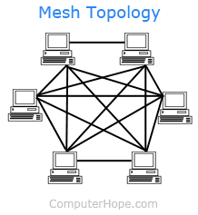

* Advantages:
* Manages high amounts of traffic, because multiple devices can transmit data simultaneously.
* A failure of one device does not cause a break in the network or transmission of data.
* Adding additional devices does not disrupt data transmission between other devices.
* Disadvantages:
* The cost to implement is higher than other network topologies, making it a less desirable option.
* Building and maintaining the topology is difficult and time consuming.
* The chance of redundant connections is high, which adds to the high costs and potential for reduced efficiency.(computerhope, 2018)
* **Bus topology.**
* Define: Alternatively referred to as line topology, bus topology is a network setup where each computer and network device is connected to a single cable or [backbone](https://www.computerhope.com/jargon/b/backbone.htm). Depending on the type of computer [network card](https://www.computerhope.com/jargon/n/nic.htm), a [coaxial cable](https://www.computerhope.com/jargon/c/coaxialc.htm) or an [RJ-45](https://www.computerhope.com/jargon/r/rj45.htm) network cable is used to connect them together.

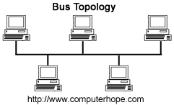

* Advantages:
* It works well when you have a small network.
* It's the easiest network topology for connecting computers or peripherals in a linear fashion.
* It requires less cable length than a star topology.
* Disadvantages:
* It can be difficult to identify the problems if the whole network goes down.
* It can be hard to troubleshoot individual device issues.
* Bus topology is not great for large networks.
* Terminators are required for both ends of the main cable.
* Additional devices slow the network down.
* If a main cable is damaged, the network fails or splits into two.(computerhope, 2018)
* **Ring topology.**
* Define:
* A ring topology is a [network](https://www.computerhope.com/jargon/n/network.htm) configuration where device connections create a circular [data](https://www.computerhope.com/jargon/d/data.htm) path. Each networked device is connected to two others, like points on a circle. Together, devices in a ring topology are referred to as a ring network.
* In a ring network, [packets](https://www.computerhope.com/jargon/p/packet.htm) of data travel from one device to the next until they reach their destination. Most ring topologies allow packets to travel only in one direction, called a unidirectional ring network. Others permit data to move in either direction, called bidirectional.
* Ring topologies may be used in either [LANs](https://www.computerhope.com/jargon/l/lan.htm) (local area networks) or [WANs](https://www.computerhope.com/jargon/w/wan.htm) (wide area networks). Depending on the [network card](https://www.computerhope.com/jargon/n/nic.htm) used in each computer of the ring topology, a [coaxial cable](https://www.computerhope.com/jargon/c/coaxialc.htm) or an [RJ-45](https://www.computerhope.com/jargon/r/rj45.htm) network cable is used to connect computers together.

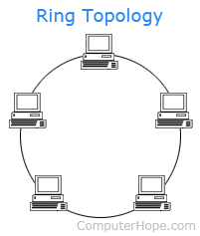

* Advantages:
* All data flows in one direction, reducing the chance of packet collisions.
* A network server is not needed to control network connectivity between each workstation.
* Data can transfer between workstations at high speeds.
* Additional workstations can be added without impacting performance of the network.
* Disadvantages:
* All data being transferred over the network must pass through each workstation on the network, which can make it slower than a [star topology](https://www.computerhope.com/jargon/s/startopo.htm).
* The entire network will be impacted if one workstation shuts down.
* The hardware needed to connect each workstation to the network is more expensive than Ethernet cards and hubs/switches.(computerhope, 2018)
* **Start topology.**
* Define: Alternatively referred to as a star network, star topology is one of the most common network setups. In this configuration, every [node](https://www.computerhope.com/jargon/n/node.htm) connects to a central network device, like a [hub](https://www.computerhope.com/jargon/h/hub.htm), [switch](https://www.computerhope.com/jargon/s/switch.htm), or computer. The central network device acts as a [server](https://www.computerhope.com/jargon/s/server.htm) and the peripheral devices act as [clients](https://www.computerhope.com/jargon/c/client.htm). In a star topology setup, either a [coaxial](https://www.computerhope.com/jargon/c/coaxialc.htm) or [RJ-45](https://www.computerhope.com/jargon/r/rj45.htm) network cable is used, depending on the type of [network card](https://www.computerhope.com/jargon/n/nic.htm) installed in each computer.

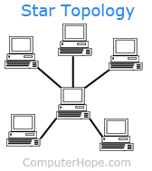

* Advantages:
* Centralized management of the network, through the use of the central computer, hub, or switch.
* Easy to add another computer to the network.
* If one computer on the network fails, the rest of the network continues to function normally.
* Disadvantages:
* May have a higher cost to implement, especially when using a switch or router as the central network device.
* The central network device determines the performance and number of nodes the network can handle.
* If the central computer, hub, or switch fails, the entire network goes down and all computers are disconnected from the network.(computerhope, 2018)
* **Tree topology.**
* Define: In computer networks, a tree topology is also known as a star bus topology. It incorporates elements of both a bus topology and a star topology.(computerhope, 2017)

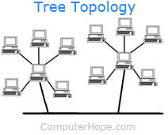

* Advantages:
* This topology is the combination of bus and star topology.
* This topology provides a hierarchical as well as central data arrangement of the nodes.
* As the leaf nodes can add one or more nodes in the hierarchical chain, this topology provides high scalability.
* The other nodes in a network are not affected, if one of their nodes get damaged or not working.
* Tree topology provides easy maintenance and easy fault identification can be done.
* A callable topology. Leaf nodes can hold more nodes.
* Supported by several hardware and software vendors.
* Point-to-point wiring for individual segments.
* Disadvantages:
* This network is very difficult to configure as compared to the other network topologies.
* Length of a segment is limited & the limit of the segment depends on the type of cabling used.
* Due to the presence of large number of nodes, the network performance of tree topology becomes a bit slowly.
* If the computer in first level is erroneous, next level computer will also go under problems.
* Requires large number of cables compared to star and ring topology.
* As the data needs to travel from the central cable this creates dense network traffic.
* The Backbone appears as the failure point of the entire segment of the network.
* Treatment of the topology is pretty complex.
* The establishment cost increases as well.
* If the bulk of nodes are added in this network, then the maintenance will become complicated.(geeksforgeeks, 2020)
* **Hybrid topology.**
* Define: Hybrid topology utilizes a mix of two or more topologies in a way that the resulting network does not exhibit one of the standard topologies (e.g., star, bus, ring, etc.) Hybrid topology combines two or more different topologies to create a resultant topology that has good points (as well as flaws) of all the constituent basic topologies instead of possessing features of one specific topology.
* Advantages:
* Reliable: It has far better fault tolerance. The section where fault is found could possibly be singled out from the rest of network and required restorative steps could be taken, without impacting the working of rest of the network.
* Effective: The most important advantage of this topology is that the weakness of the different topologies connected are disregarded and only the strengths are taken into consideration. For instance, ring topology has good data reliability and star topology has high tolerance capability, so these two functions quite well in hybrid star-ring topology.
* Flexible: One of the key advantages of this topology is its flexibility. The topology is created, so that it can be implemented for a variety of distinct network environment. Hybrid Network can be created in line with the demands of the corporation and by maximizing the available resources.
* Scalable: Hybrid networks are built in a fashion which enables for easy integration of new hardware components like additional concentration points. It’s quite simple to extend the size of network with the addition of new elements, without disturbing existing architecture.
* Disadvantages:
* Complexity: Due to the fact that different topologies connect in a hybrid topology, managing the topology gets challenging. It’s not easy to design this type of architecture and it’s a difficult job for designers. Configuration and installation process needs to be very efficient.
* Expensive: The network hubs needed for hybrid topology networking are costly to purchase and maintain. The cost of this topology is higher in comparison to the other topologies. The hubs used to connect two distinct networks are expensive. These hubs are not the same as usual hubs since they have to be smart enough to work with different architectures and should be able to operate even when a portion of network is down. As hybrid architectures are usually larger in scale, they may require a lot of cables, advanced network devices, etc.(universalteacher, 2021)

1. **What is network communication?**

Define: A network is a set of computers connected through a transmission medium, to transmit and receive [information](https://ecomputernotes.com/fundamental/information-technology/what-do-you-mean-by-data-and-information) from other computers in the network. You can also define a network as a set of devices (often called nodes) connected by links from a physical medium. A node can be a [computer](https://ecomputernotes.com/fundamental/introduction-to-computer/what-is-computer), a [printer](https://ecomputernotes.com/fundamental/input-output-and-memory/what-is-a-printer-and-what-are-the-different-types-of-printers), or any other device capable of sending and receiving data generated by other nodes of the network. The links connected to the devices, often referred to as communication channels.(ecomputernotes, 2021)

The rules in network: In my view, when we use network, we need to have some rules.

* We need to define your purpose when using the network.
* We need to know common language and grammar to use network better.
* We need to understand about network.

In my opinion, the above 3 rules are the basic rules that we need to know when using the network to avoid using the network to do wrong things and potential victims of the hackers.

1. **What is bandwidth?**

Define: Bandwidth is a term related to digital communications. It refers to the bit-rate of the available or exhausted information capacity in digital networking. In simpler words, bandwidth is synonymous to the exact rate of data transfer. It refers to the exact amount of data that can be carried between two data points at a specified time period. Generally, network bandwidth is expressed metrically in the form of bits per seconds (BPS). However, the modern networks now measure their speeds in millions of bits every second, which is also referred as megabits per second (MBPS). Similarly, billions of bits every second, referred as gigabits per second (Gbps).

Why bandwidth is needed for network: Bandwidth is highly significant for determining how fast a web page loads on a browser. In fact, it is also one of the essential things to consider while you’re choosing a platform for web hosting. The bandwidth can be significantly affected by the website and the internet connection used for accessing it. Generally, a website loaded with heavy graphics will need higher bandwidth of 10 gigs or more. Similarly, a simpler website will require comparatively lesser bandwidth. Just as fast internet connection allows you to download web pages and videos flawlessly, higher bandwidth will effectively improvise the user experience and let your users avail the very best from your website.(Belyh, 2015)

1. **Discuss the operating principles of networking devices and server types (P3)**
2. **Some popular network devices and how these devices operate in a network.**

* **Switch.**
* Define:
* Switches are networking devices operating at layer 2 or a data link layer of the OSI model. They connect devices in a network and use packet switching to send, receive or forward data packets or data frames over the network.
* A switch has many ports, to which computers are plugged in. When a data frame arrives at any port of a network switch, it examines the destination address, performs necessary checks and sends the frame to the corresponding device(s). It supports unicast, multicast as well as broadcast communications.

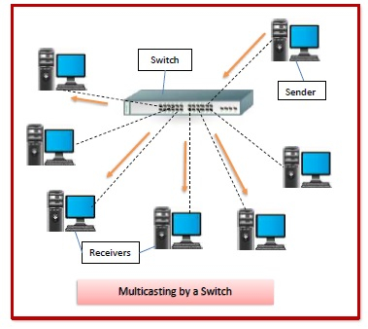

* Features of Switches:
* A switch operates in the layer 2, i.e. data link layer of the OSI model.
* It is an intelligent network device that can be conceived as a multiport network bridge.
* It uses MAC addresses (addresses of medium access control sublayer) to send data packets to selected destination ports.
* It uses packet switching technique to receive and forward data packets from the source to the destination device.
* It is supports unicast (one-to-one), multicast (one-to-many) and broadcast (one-to-all) communications.
* Transmission mode is full duplex, i.e. communication in the channel occurs in both the directions at the same time. Due to this, collisions do not occur.
* Switches are active devices, equipped with network software and network management capabilities.
* Switches can perform some error checking before forwarding data to the destined port.
* The number of ports is higher – 24/48. (tutorialspoint, 2021)
* **Router.**
* Define: Routers are networking devices operating at layer 3 or a network layer of the OSI model. They are responsible for receiving, analysing, and forwarding data packets among the connected computer networks. When a data packet arrives, the router inspects the destination address, consults its routing tables to decide the optimal route and then transfers the packet along this route.

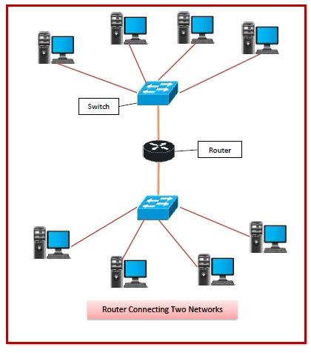

* Features of Routers:
* A router is a layer 3 or network layer device.
* It connects different networks together and sends data packets from one network to another.
* A router can be used both in LANs (Local Area Networks) and WANs (Wide Area Networks).
* It transfers data in the form of IP packets. In order to transmit data, it uses IP address mentioned in the destination field of the IP packet.
* Routers have a routing table in it that is refreshed periodically according to the changes in the network. In order to transmit data packets, it consults the table and uses a routing protocol.
* In order to prepare or refresh the routing table, routers share information among each other.
* Routers provide protection against broadcast storms.
* Routers are more expensive than other networking devices like hubs, bridges and switches. (tutorialspoint, 2021)
* **Hub.**
* Define:
* Hubs are networking devices operating at a physical layer of the OSI model that are used to connect multiple devices in a network. They are generally used to connect computers in a LAN.
* A hub has many ports in it. A computer which intends to be connected to the network is plugged in to one of these ports. When a data frame arrives at a port, it is broadcast to every other port, without considering whether it is destined for a particular destination device or not.

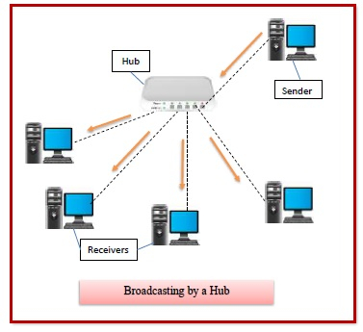

* Features of Hubs:
* A hub operates in the physical layer of the OSI model.
* A hub cannot filter data. It is a non-intelligent network device that sends message to all ports.
* It primarily broadcasts messages. So, the collision domain of all nodes connected through the hub stays one.
* Transmission mode is half duplex.
* Collisions may occurs during setup of transmission when more than one computers place data simultaneously in the corresponding ports.
* Since they lack intelligence to compute best path for transmission of data packets, inefficiencies and wastage occur.
* They are passive devices, they don’t have any software associated with it.
* They generally have fewer ports of 4/12. (tutorialspoint, 2021)
* **Bridge.**
* Define: Bridges are used to connect two subnetworks that use interchangeable protocols. It combines two LANs to form an extended LAN. The main difference between the bridge and repeater is that the bridge has a penetrating efficiency.

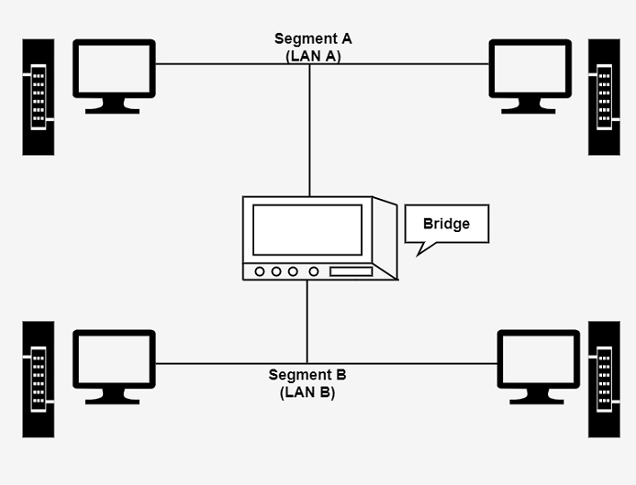

* Features of Bridges: A bridge accepts all the packets and amplifies all of them to the other side. The bridges are intelligent devices that allow the passing of only selective packets from them. A bridge only passes those packets addressed from a node in one network to another node in the other network.(tutorialspoint, 2021)
* **Modem.**
* There are two types of Modems:
* Standard Modem.
* Window Modem.
* Standard Modem definition:

The standard modems use generic device drivers, and they can be internal and external ones. The internal modems do not need much physical structure. They can be installed into a compatible development slot. The external modem is connected through one of the COM port to the computer through a cable called a null-modem cable.

* Window Modem definition:

A window modem is a private plug and plays tool. It requires a particular device driver supported by the window operating framework to function correctly.

* Features of Modems:
* They have high uploading and communication rates. An X2 modem provides an uploading bandwidth between 28.8 to 56 Kbps.
* They are upgradeable through a software patch to meet almost any universal standard.
* They enable high-speed downstream data transfers by digitally encoding all downstream data while upstream runs at conventional rates of 33.6 kbps.
* Some modems incorporate dual simultaneous voice and Data (DSVD), i.e., they can carry both analog voices and computer data.
* They can detect callers originating telephone number, and thus they can serve as caller ID.
* Some modems provide advanced voice mail features, and those modems serve as intelligent, answering machines or digital information systems.(tutorialspoint, 2021)

1. **Some other common networking devices and specify their uses, and under what circumstances.**

* **Gateway.**
* Define:

A gateway is a network node that forms a passage between two networks operating with different transmission protocols. The most common type of gateways, the network gateway operates at layer 3, i.e. network layer of the OSI (open systems interconnection) model. However, depending upon the functionality, a gateway can operate at any of the seven layers of OSI model. It acts as the entry – exit point for a network since all traffic that flows across the networks should pass through the gateway. Only the internal traffic between the nodes of a LAN does not pass through the gateway.

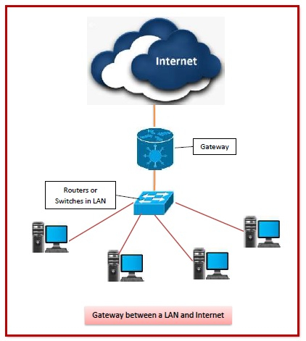

* Features of Gateways:
* Gateway is located at the boundary of a network and manages all data that inflows or outflows from that network.
* It forms a passage between two different networks operating with different transmission protocols.
* A gateway operates as a protocol converter, providing compatibility between the different protocols used in the two different networks.
* The feature that differentiates a gateway from other network devices is that it can operate at any layer of the OSI model.
* It also stores information about the routing paths of the communicating networks.
* When used in enterprise scenario, a gateway node may be supplemented as proxy server or firewall.
* A gateway is generally implemented as a node with multiple NICs (network interface cards) connected to different networks. However, it can also be configured using software.
* It uses packet switching technique to transmit data across the networks.(tutorialspoint, 2021)
* **Firewall.**
* Define: A firewall is a security device in the form of computer hardware or software. It can help protect your network by acting as an intermediary between your internal network and outside traffic. It monitors attempts to gain access to your operating system and blocks unwanted incoming traffic and unrecognized sources.
* How does firewall work?

A firewall acts as a barrier or gatekeeper between your computer and another network like the internet. It works like a traffic controller, monitoring and filtering traffic that wants to gain access to your operating system. (norton, 2021)

* When is a firewall used?

In my view, the firewall is often used in companies and enterprises to protect their network. Avoiding intrusion of malicious codes and hackers want to access to their network.

* **Repeater.**
* Define:
* A repeater is a network device that retransmits a received signal with more power and to an extended geographical or topological network boundary than what would be capable with the original signal.
* A repeater is implemented in computer networks to expand the coverage area of the network, repropagate a weak or broken signal and or service remote nodes. Repeaters amplify the received/input signal to a higher frequency domain so that it is reusable, scalable and available.
* Repeaters were introduced in wired data communication networks due to the limitation of a signal in propagating over a longer distance and now are a common installation in wireless networks for expanding cell size.
* Repeaters are also known as signal boosters.
* How does Repeater work and when is a Repeater used?
* Every operational computer or data communications network has a specific boundary in which it can service the connected and authorized hosts/nodes. It is a planned network scope, but sometimes the network needs to extend its routing domain further to accommodate a new/existing host, or to improve the service level in a specific topological domain. In such scenarios, a network uses the service of a repeater, which amplifies the received signal to an ideal or near-ideal strength so that destination/receiving nodes can receive the data.
* The installation of repeaters is critical in those domains, where attenuation and signal loss is very crucial. Repeaters are generally considered to be nonlogical devices because they propagate every signal regardless of its size, type, etc. Repeaters support both analog and digital signals and can repeat electrical and light-based signals.(techopedia, 2015)

1. **Some common types of servers and state the use of each server type.**

* **File Server:** A Special server is designed specifically for use as Storage , reading and writing files into a file server. A file server is a computer joined to a network in home or office Network, and that can store many files in the server’s hard disks. a shared disk access, i.e. shared storage of computer files Connectivity by FTP ( File Transfer Protocol ), SMB/CIFS protocol (Windows and Unix-like) or NFS protocol (Unix-like systems). Design of File Server RAID (Redundant Array of Independent Disks) and NAS (Network Storage Network).

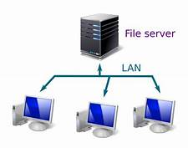

* **Web Server:** A Web server online static web page content display to a Web browser by loading a file from a disk and serving it across the network to a user’s Web browser. This entire exchange is mediated by the browser and server talking to each other using HTTP.

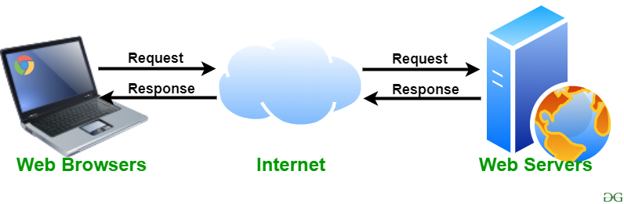

* **DNS Server:**
* A DNS server is a computer server that contains a database of public IP addresses and their associated Hostnames, and in most cases serves to resolve, or translate, those names to IP addresses as requested. DNS servers run special software and communicate with each other using special protocols.
* A user enters a Website name called domain name into their Internet browser. (www.ahirlabs.com). The computer sends the domain name as a DNS request to the ISP (Internet Service Provider).The ISP finds IP address associated with that name. If not, the ISP forwards the request to other providers in an effort to located the DNS record that contains the data. Once the record is found, the IP address of the domain is returned to the user. the user’s computer can communicate directly with the server.

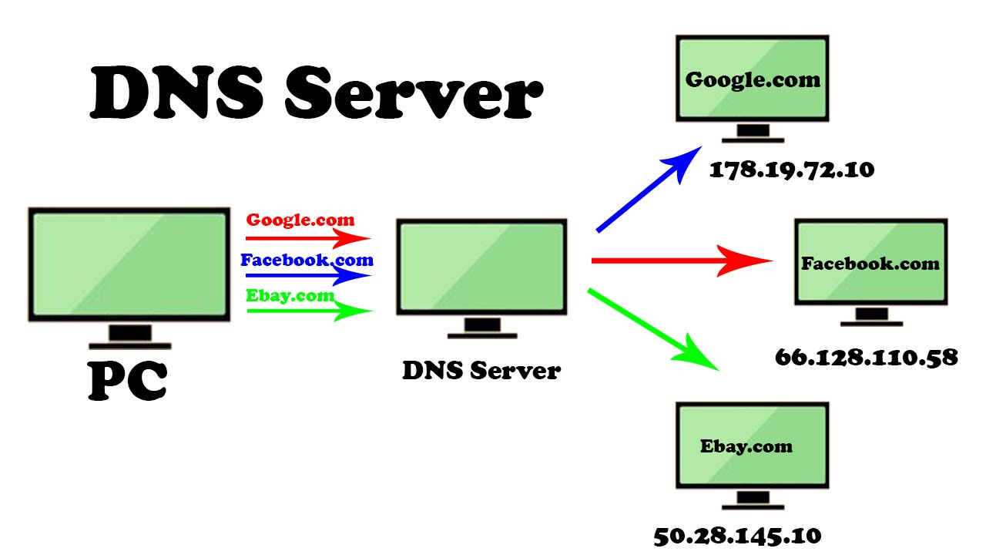

* **FTP Server:** File Transfer Protocol makes it possible to move one or more files securely between computers while providing file security and organisation as well as transfer control.FTP is transferring files from server to a computer and vice versa.

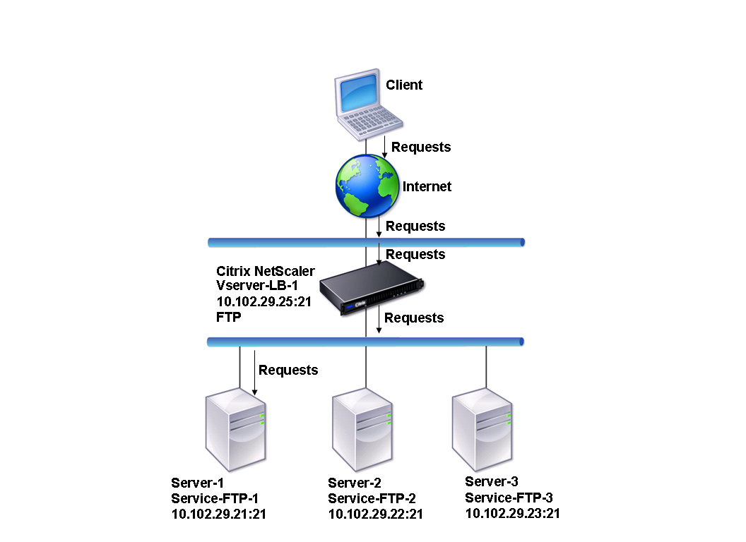

* **Mail Server:** Mail servers is mail Storage of Received Mails, Send Mails across the Internet.Like a Web servers, mail servers move and store mail to networks (via LANs and WANs) and across the Internet. Today, every person use mail.

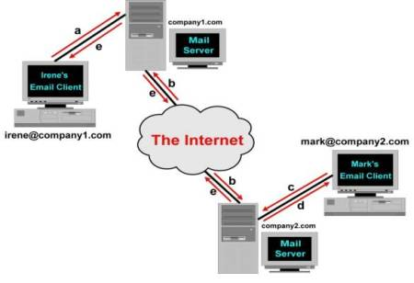

* **Print Servers:** A Print Server Manage Multiple Printers with a software application, network device or computer. To makes a printer queue status information available to end users and network administrators.a Print Server is mainly used in Office or Where More 20-50 Users are need to Printing It accepts print jobs task from the computers and sends the jobs to the appropriate printers, queuing the jobs locally to schedule it so more quickly than the printer Print. (ahirlabs, 2021)

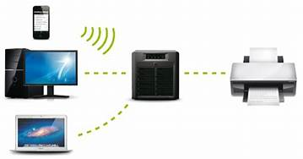

1. **Discuss the inter-dependence of workstation hardware with relevant networking software (P4)**
2. **The meaning of interdependence.**

* **Define:** Interdependence is a connection between subjects where one subject’s needs can be fulfilled by the other subject’s resources and these transfer of resources works both ways. That means both subjects need each other to fulfill their needs. These kinds of relationships can be found almost everywhere since, as humans, we need other people’s help to survive and strive. In the business field, organizations depend on each other in many different levels.
* **Example:**
* A business called City Wheels Co. is a bike rental venture that serves the city of Los Angeles. The company leases bikes to individuals for given periods of time and they have locations all around the city to pick-up and deliver the bikes. From the perspective of interdependence we can identify at least two essential interdependent relationships between the business and other parties.
* First of all, City Wheels and its clients are interdependent since these individuals need the bikes for transportation and the company also depends on them to earn the revenues they need to remain operational. And second of all, there’s also interdependence with bike mechanics and bike suppliers, since in both cases these suppliers depend on the company to keep their business running and City Wheels depends on them to keep its business well equipped to serve its clients. (myaccountingcourse, 2021)

1. **What is workstation hardware and networking software?**

* **Workstation hardware.**
* A work station is a computer intended for individual use that is faster and more capable than a personal computer. Since they are PCs, they can also be used independently of the mainframe assuming they have their own applications installed and their own hard disk storage.
* Network interface card is a computer hardware part that enables computers to be combined together in a network usually a local area network. Computers that are networked always communicate with each other using a specified protocol for transferring data packets. Network Interface Card acts as a translator letting machine mutually send and obtain data on a LAN. Specialists in information system frequently use these cards to setup wireless or wired connections networks. (Muyobo, 2021)
* **Networking software.**
* Define: Network software encompasses a broad range of software used for design, implementation, and operation and monitoring of computer networks. Traditional networks were hardware based with software embedded. With the advent of Software – Defined Networking (SDN), software is separated from the hardware thus making it more adaptable to the ever-changing nature of the computer network.
* Functions of network software.
* Helps to set up and install computer networks
* Enables users to have access to network resources in a seamless manner
* Allows administrations to add or remove users from the network
* Helps to define locations of data storage and allows users to access that data
* Helps administrators and security system to protect the network from data breaches, unauthorized access and attacks on a network
* Enables network virtualizations (tutorialspoint, 2021)

1. **The independence of the workstation hardware and networking software.**

* Hardware and software are mutually dependent on each other. Both of them must work together to make a computer produce a useful output.
* Software cannot be utilized without supporting hardware.
* Hardware without set of programs to operate upon cannot be utilized and is useless. To get a particular job done on the computer, relevant software should be loaded into the hardware
* Hardware is a one-time expense.
* Software development is very expensive and is a continuing expense.
* Different software applications can be loaded on a hardware to run different jobs.
* A software acts as an interface between the user and the hardware.
* If hardware is the 'heart' of a computer system, then software is its 'soul'. Both are complimentary to each other. (tutorialspoint, 2021)

1. **Compare common networking principles and how protocols enable the effectiveness of networked systems (M1)**
2. **Circuit switching.**

Define: Circuit switching is when a dedicated channel or circuit needs to be established before users can speak to each other on a call. A channel used in circuit switching is kept reserved at all times and is used once the two users communicate.

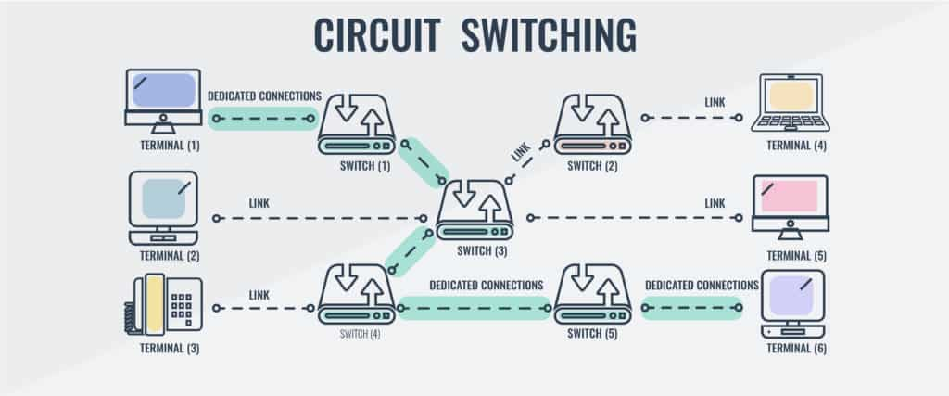

1. **Packet switching.**

Packet switching is different from circuit switching because there is no requirement to establish a channel. The channel is available to users throughout the data network. Long messages are broken down into packets and sent individually to the network.

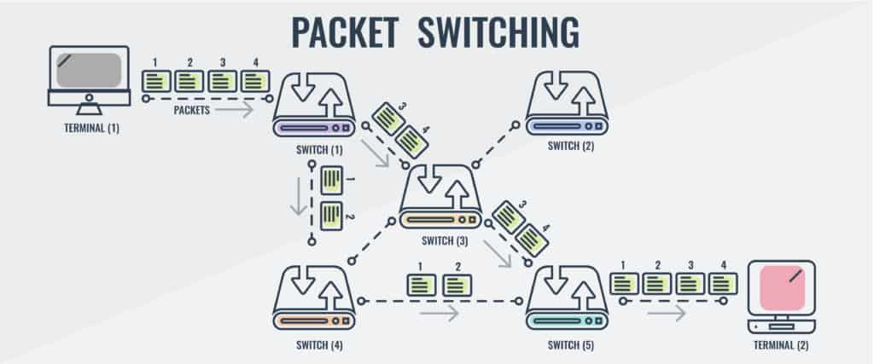

1. **Circuit Switching vs Packet Switching Comparison.**

|  |  |  |
| --- | --- | --- |
| **Features** | **Circuit switching** | **Packet switching** |
| Dedicated Path | yes | no |
| Path Formation | Path dedicated for one conversation | Route is established on a per packet basis of the conversation using datagram (or per conversation with virtual circuit) |
| Delay | Call setup delay | Packet transmission delay (call setup delay for virtual circuit) |
| Bandwidth Type | Fixed Bandwidth | Dynamic bandwidth |
| Overload Effects | Stops call establishment | Increases packet delay (can block call establishment and increase packet delay with virtual circuit) |

1. **The Advantages and Disadvantages of Circuit Switching.**

* Advantages:
* The circuit switching model has become popular for many different reasons. One of the main reasons is that it decreases the amount of delay the user experiences before and during a call. Circuit switching is adept at making sure that delay is minimized during phone calls so that the callers can enjoy the best end-user experience possible. Packet switching is unable to sustain the same standard of service to users throughout the call.
* Under circuit switching the call will be provided with consistent bandwidth, channels, and an ongoing data rate. As a consequence, the user is able to stay on the phone for longer periods of connection time without running into any performance issues. Circuit switching also has the advantage of making sure that data packets are delivered in their correct sequence. The lower level of delay makes sure that data packets are delivered in order so that all the content in the call can be understood.
* Disadvantages:
* The circuit switching model has become popular for many different reasons. One of the main reasons is that it decreases the amount of delay the user experiences before and during a call. Circuit switching is adept at making sure that delay is minimized during phone calls so that the callers can enjoy the best end-user experience possible. Packet switching is unable to sustain the same standard of service to users throughout the call.
* Under circuit switching the call will be provided with consistent bandwidth, channels, and an ongoing data rate. As a consequence, the user is able to stay on the phone for longer periods of connection time without running into any performance issues. Circuit switching also has the advantage of making sure that data packets are delivered in their correct sequence. The lower level of delay makes sure that data packets are delivered in order so that all the content in the call can be understood.

1. **The Advantages and Disadvantages of Packet Switching.**

* Advantages:
* While packet switching may not be as suited to voice calls as circuit switching, it has a number of advantages that are hard to ignore. The main advantage that packet switching has over circuit switching is its efficiency. Packets can find their own data paths to their destination address without the need for a dedicated channel. In contrast, in-circuit switching network devices can’t use the channel until the voice communication has been terminated.
* Packet switching is also reliable because it helps to eliminate [packet loss](https://www.comparitech.com/net-admin/how-to-fix-packet-loss/). With packet switching, data packets can be resent if they don’t reach their destination. This isn’t the case for circuit switching which doesn’t have the means to send lost packets. As a result, packet switching is the more reliable method of the two because it ensures that packets reach their destination.
* Packet switching also reduces the costs associated with running the network. Packet switching networks can transfer general network traffic and voice traffic across the network without the need for a dedicated channel. This saves you money because you don’t need to pay to have one channel available for voice communications.
* Disadvantages:
* The biggest limitation of packet switching is that it is unsuitable for applications that require minimal latency. In a network that uses lots of voice calls circuit switching is a necessity because it is the only setup that delivers a high-quality end call. Packet switching can only provide a voice call experience that results in choppy audio that makes it difficult for the users to understand each other.
* Similarly, though packet switching is able to resend lost data packets, this isn’t the case if the network becomes overwhelmed by traffic. If there is too much traffic then packets will be dropped in transit. The end result is the loss of important data. This risk is further increased by the lack of security protocols used to protect packets during data transmission. There is no [IPsec](https://www.comparitech.com/blog/information-security/ipsec-encryption/) to give packets that extra barrier of security against damage. Though packet switching reduces costs in a number of ways it is significantly expensive to implement. Packet switching relies on a range of complex protocols that must be managed from deployment onward.(comparitech, 2020)

1. **The protocols enable networked systems to connect efficiently using Circuit Switching principle.**

* TDM (Time Division Multiplexing): Divides into frames

Time-division multiplexing (TDM) is a method of transmitting and receiving independent signals over a common signal path by means of synchronized switches at each end of the transmission line. TDM is used for long-distance communication links and bears heavy data traffic loads from end user.   
Time division multiplexing (TDM) is also known as a digital circuit switched.

* FDM (Frequency Division Multiplexing): Divides into multiple bands

Frequency Division Multiplexing or FDM is used when multiple data signals are combined for simultaneous transmission via a shared communication medium.It is a technique by which the total bandwidth is divided into a series of non-overlapping frequency sub-bands,where each sub-band carry different signal. Practical use in radio spectrum & optical fiber to share multiple independent signals. (geeksforgeeks, 2021)

1. **The protocols enable networked systems to connect efficiently using Packet Switching principle.**

* Connection-oriented Packet Switching.

This is also known as virtual circuit switching, which requires a setup phase or virtual connection to establish a path before transmission. With signaling protocol, a predefined path is set up to enable the sender, receiver and all packets of the same message to follow this path. Switches/routers provide [virtual](https://www.elprocus.com/what-is-virtual-lan-architecture-types-of-links-differences/) circuit ID to recognize the virtual connection. The data in this type of switching is split into small units. A sequence number is added to these small units. In this process, three phases are described. They are set up, data transfer, and tear down phase.

* Connectionless Packet Switching.
* Connectionless type Switching is popularly known as datagram switching. Here, each packet comprises a source and destination address and port address and other necessary information. Sometimes, the packets are labeled with a sequence number.
* In datagram packet switching, the packets traverse independently and in different routes and so the packets that arrive at the destination might be out-of-order delivery. As packets arrive at the destination in an unordered format, the original message shall be retrieved based on the sequence numbers of the packets.
* Reliable delivery of packets in connectionless switching is not guaranteed. So, providing end-to-end systems with additional protocols is needed.(elprocus, 2021)

1. **Explore a range of server types and justify the selection of a server, considering a given scenario regarding cost and performance optimisation (M2)**
2. **Explore a range of common server types and give a brief outline of their uses.**

* DNS (Domain Name System):

How does DNS work?

* The process of DNS resolution involves converting a hostname (such as www.example.com) into a computer-friendly IP address (such as 192.168.1.1). An IP address is given to each device on the Internet, and that address is necessary to find the appropriate Internet device - like a street address is used to find a particular home. When a user wants to load a webpage, a translation must occur between what a user types into their web browser (example.com) and the machine-friendly address necessary to locate the example.com webpage.
* In order to understand the process behind the DNS resolution, it’s important to learn about the different hardware components a DNS query must pass between. For the web browser, the DNS lookup occurs "behind the scenes" and requires no interaction from the user’s computer apart from the initial request.(cloudflare, 2021)
* DHCP

How does DHCP work?

DHCP works at the application layer to dynamically assign the IP address to the client and this happens through the exchange of a series of messages called DHCP transactions or DHCP conversation.(afteracademy, 2020)

1. **My choice for this scenario.**

* In this part, I will choose DNS server to talk about it. DNS will help us to improve network stability. we don't need to memorize IP addresses -DNS Servers will provide a convenient solution for converting domain names or subdomains to IP addresses. In my opinion, for a company, using a DNS server is indispensable. I think the price of using a DNS server is not expensive for a small and medium-sized company like in the scenario.

1. **Considering a given scenario, identify the topology protocol selected for the efficient utilization of a networking system (D1)**
2. **Scenario.**

You are employed as a network engineer by Nguyen Networking Limited, a high-tech networking solution development company, which has branches in Ho Chi Minh City, Hanoi, Da Nang and Can Tho. The company has been contracted to implement a networking project from a local educational institute. The specification of the project is given below:

* People: 200 students, 15 teachers, 12 marketing and administration staff, 5 higher managers including the academic heads and the programme managers, and 3 computer network administrators.
* Resources: 50 student lab computers, 35 staff computers, and 3 printers.
* Building: 3 floors, all computers and printers are on the ground floor apart from the IT labs – one lab located on the first floor and another located on the second floor.

1. **My solution.**

In this scenario. I will choose hybrid topology to use for. I choose this topology because in this scenario the company have three floor and if I use hybrid topology, it will be more flexible.

* Advantages of this topology:
* we will fix it easier if this topology get problem.
* It will be flexible than those topology because it will make less mistakes.
* Easy to install and maintenance.
* It has far better fault tolerance.
* Disadvantages of this topology:
* The cost when using this topology I think it will be expensive for a small or medium company.
* It will spend lots of devices.
* It is quite complex because having lots of topologies connect each other.

# References

afteracademy, 2020. *what-is-dhcp-and-how-does-it-work.* [Online]   
Available at: https://afteracademy.com/blog/what-is-dhcp-and-how-does-it-work  
[Accessed 11 12 2021].

ahirlabs, 2021. *list-of-different-types-of-servers.* [Online]   
Available at: https://www.ahirlabs.com/2019/05/08/list-of-different-types-of-servers/  
[Accessed 9 12 2021].

Belyh, A., 2015. *bandwidth.* [Online]   
Available at: https://www.cleverism.com/lexicon/bandwidth/  
[Accessed 9 12 2021].

byjus, 2021. *osi-model-open-systems-interconnection.* [Online]   
Available at: https://byjus.com/govt-exams/osi-model-open-systems-interconnection/  
[Accessed 12 9 2021].

cloudflare, 2021. */what-is-dns.* [Online]   
Available at: https://www.cloudflare.com/learning/dns/what-is-dns/  
[Accessed 11 12 2021].

cloudflare, 2021. *what-is-a-protocol.* [Online]   
Available at: https://www.cloudflare.com/learning/network-layer/what-is-a-protocol/  
[Accessed 5 12 2021].

comparitech, 2020. *circuit-switching-vs-packet-switching.* [Online]   
Available at: https://www.comparitech.com/net-admin/circuit-switching-vs-packet-switching/  
[Accessed 11 12 2021].

computerhope, 2017. *treetopo.* [Online]   
Available at: https://www.computerhope.com/jargon/t/treetopo.htm  
[Accessed 6 12 2021].

computerhope, 2018. *bustopol.* [Online]   
Available at: https://www.computerhope.com/jargon/b/bustopol.htm  
[Accessed 6 12 2021].

computerhope, 2018. *mesh.* [Online]   
Available at: https://www.computerhope.com/jargon/m/mesh.htm  
[Accessed 6 12 2021].

computerhope, 2018. *ringtopo.* [Online]   
Available at: https://www.computerhope.com/jargon/r/ringtopo.htm  
[Accessed 6 12 2021].

computerhope, 2018. *startopo.* [Online]   
Available at: https://www.computerhope.com/jargon/s/startopo.htm  
[Accessed 6 12 2021].

ecomputernotes, 2021. *communication-network.* [Online]   
Available at: https://ecomputernotes.com/computernetworkingnotes/communication-networks/communication-network  
[Accessed 6 12 2021].

elprocus, 2021. *what-is-a-packet-switching-modes-and-delays.* [Online]   
Available at: https://www.elprocus.com/what-is-a-packet-switching-modes-and-delays/  
[Accessed 11 12 2021].

geeksforgeeks, 2020. *advantages-and-disadvantages-of-tree-topology.* [Online]   
Available at: https://www.geeksforgeeks.org/advantages-and-disadvantages-of-tree-topology/  
[Accessed 6 12 2021].

geeksforgeeks, 2020. *difference-between-physical-and-logical-topology.* [Online]   
Available at: https://www.geeksforgeeks.org/difference-between-physical-and-logical-topology/  
[Accessed 6 12 2021].

geeksforgeeks, 2021. *circuit-switching-in-computer-network.* [Online]   
Available at: https://www.geeksforgeeks.org/circuit-switching-in-computer-network/  
[Accessed 11 12 2021].

hitechwhizz, 2020. *advantages-and-disadvantages-drawbacks-benefits-of-pan.* [Online]   
Available at: https://www.hitechwhizz.com/2020/07/6-advantages-and-disadvantages-drawbacks-benefits-of-pan.html  
[Accessed 5 12 2021].

ionos, 2020. *what-is-a-network.* [Online]   
Available at: https://www.ionos.com/digitalguide/server/know-how/what-is-a-network/  
[Accessed 5 12 2021].

itrelease, 2021. *advantages-and-disadvantages-of-local-area-network-lan.* [Online]   
Available at: https://www.itrelease.com/2018/07/advantages-and-disadvantages-of-local-area-network-lan/  
[Accessed 5 12 2021].

javatpoin, 2021. *types-of-computer-network.* [Online]   
Available at: https://www.javatpoint.com/types-of-computer-network  
[Accessed 5 12 2021].

javatpoint, 2021. *types-of-computer-network.* [Online]   
Available at: https://www.javatpoint.com/types-of-computer-network  
[Accessed 5 12 2021].

manageengine, 2021. *network-protocols.* [Online]   
Available at: https://www.manageengine.com/network-monitoring/network-protocols.html  
[Accessed 5 12 2021].

mnccertified, 2021. *what-is-the-purpose-of-protocols-in-data-communications.* [Online]   
Available at: https://www.mnccertified.com/what-is-the-purpose-of-protocols-in-data-communications-2/  
[Accessed 5 12 2021].

Muyobo, C., 2021. *transtutors.* [Online]   
Available at: https://www.transtutors.com/questions/discuss-the-interdependence-of-workstation-hardware-with-relevant-networking-softwar-2824686.htm?fbclid=IwAR1bJoVt7kxEbQQveDrGkC7CbG2H33TTSiizDHndOGHtJsz4uzea2oaXWdQ  
[Accessed 11 12 2021].

myaccountingcourse, 2021. *interdependence.* [Online]   
Available at: https://www.myaccountingcourse.com/accounting-dictionary/interdependence  
[Accessed 10 12 2021].

norton, 2021. *internetsecurity-emerging-threats-what-is-firewall.* [Online]   
Available at: https://us.norton.com/internetsecurity-emerging-threats-what-is-firewall.html  
[Accessed 9 12 2021].

study, 2021. *organizations-that-create-networking-standards.* [Online]   
Available at: https://study.com/academy/lesson/organizations-that-create-networking-standards.html  
[Accessed 6 12 2021].

techopedia, 2012. *logical-topology.* [Online]   
Available at: https://www.techopedia.com/definition/25890/logical-topology  
[Accessed 6 12 2021].

techopedia, 2015. *repeater.* [Online]   
Available at: https://www.techopedia.com/definition/3176/repeater  
[Accessed 9 12 2021].

techopedia, 2017. *physical-topology.* [Online]   
Available at: https://www.techopedia.com/definition/4794/physical-topology  
[Accessed 6 12 2021].

techopedia, 2017. *topology.* [Online]   
Available at: https://www.techopedia.com/definition/9745/topology  
[Accessed 11 12 2021].

tutorialspoint, 2021. *computer_hardware.* [Online]   
Available at: https://www.tutorialspoint.com/computer_fundamentals/pdf/computer_hardware.pdf  
[Accessed 11 12 2021].

tutorialspoint, 2021. *Network-Software.* [Online]   
Available at: https://www.tutorialspoint.com/Network-Software  
[Accessed 11 12 2021].

tutorialspoint, 2021. *what-are-bridges-in-computer-network.* [Online]   
Available at: https://www.tutorialspoint.com/what-are-bridges-in-computer-network  
[Accessed 9 12 2021].

tutorialspoint, 2021. *what-are-gateways-in-computer-network.* [Online]   
Available at: https://www.tutorialspoint.com/what-are-gateways-in-computer-network  
[Accessed 9 12 2021].

tutorialspoint, 2021. *what-are-hubs-in-computer-network.* [Online]   
Available at: https://www.tutorialspoint.com/what-are-hubs-in-computer-network  
[Accessed 10 12 2021].

tutorialspoint, 2021. *what-are-routers-in-computer-network.* [Online]   
Available at: https://www.tutorialspoint.com/what-are-routers-in-computer-network  
[Accessed 10 12 2021].

tutorialspoint, 2021. *what-are-switches-in-computer-network.* [Online]   
Available at: https://www.tutorialspoint.com/what-are-switches-in-computer-network  
[Accessed 10 12 2021].

tutorialspoint, 2021. *what-are-the-advantages-and-disadvantages-of-lan-in-computer-network.* [Online]   
Available at: https://www.tutorialspoint.com/what-are-the-advantages-and-disadvantages-of-lan-in-computer-network  
[Accessed 5 12 2021].

tutorialspoint, 2021. *what-is-modem-in-computer-network.* [Online]   
Available at: https://www.tutorialspoint.com/what-is-modem-in-computer-network  
[Accessed 9 12 2021].

universalteacher, 2021. *advantages-and-disadvantages-of-hybrid-topology.* [Online]   
Available at: https://universalteacher.com/1/advantages-and-disadvantages-of-hybrid-topology/  
[Accessed 6 12 2021].